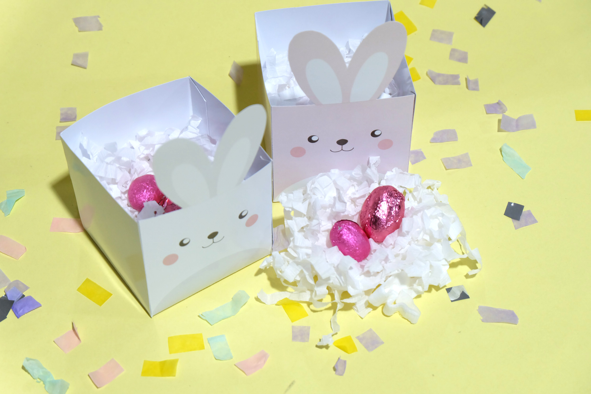

Time to hop on to easter festive mood ! Learn how to make this bunny easter eggs box that’s not only super cute but also super easy and quick to make.

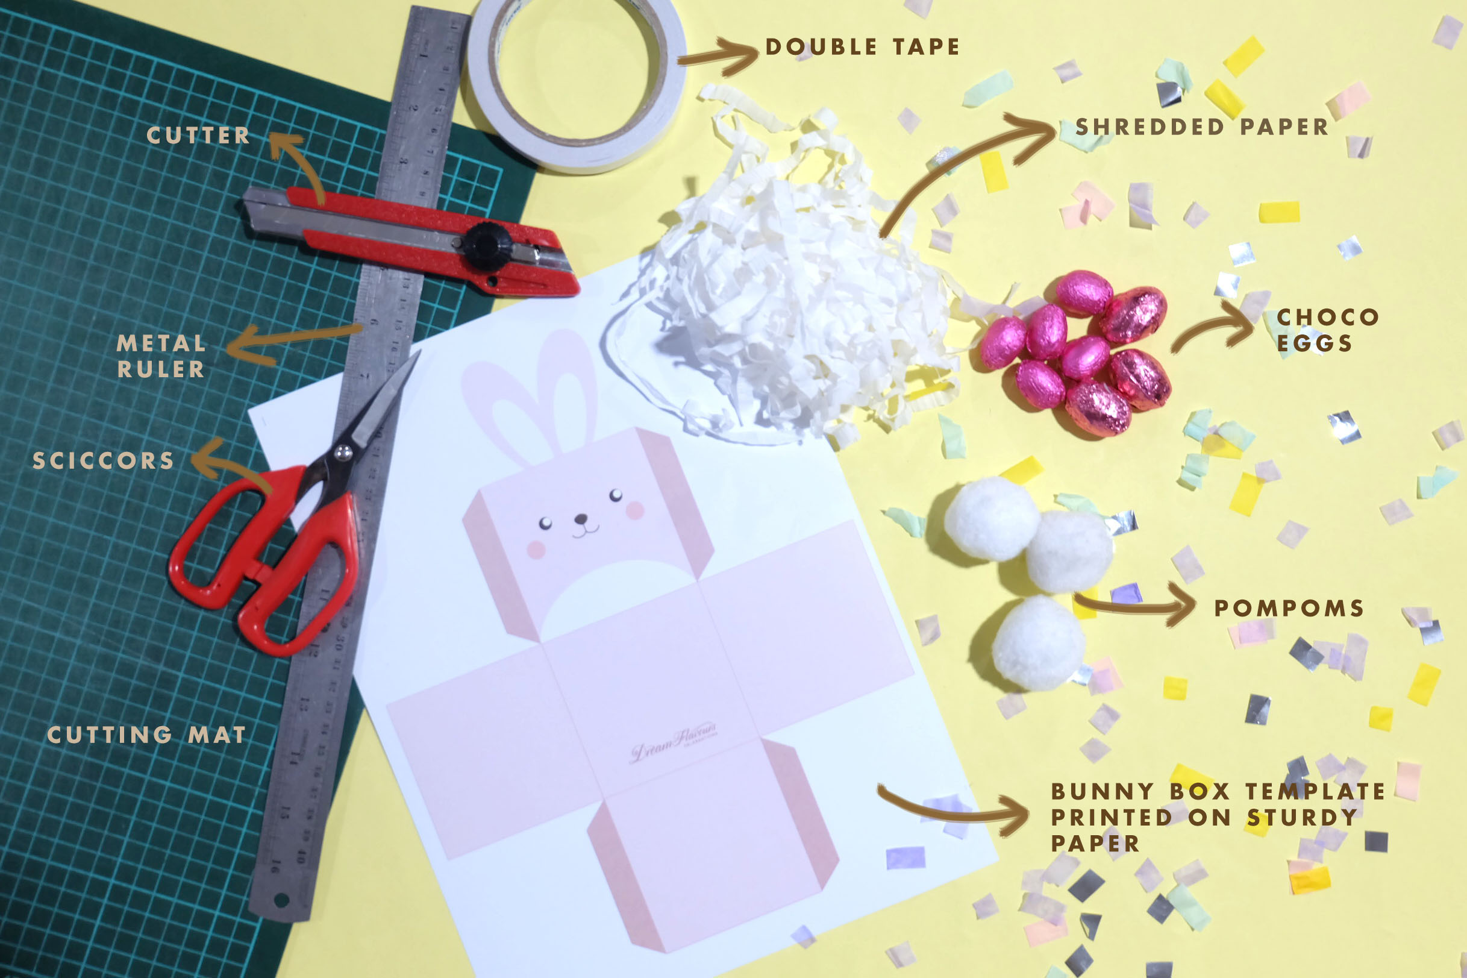

Y O U W I L L N E E D :
- DreamFlavours’ bunny box template printed on sturdy A4 Paper
- 4cm diameter pom poms
- Shredded paper
- Choco eggs / kinder eggs (or any egg shaped candy you like)

T O O L S :
- Scissors
- Cutter
- Metal Ruler
- Cutting mat
- Double Tape
- Glue gun

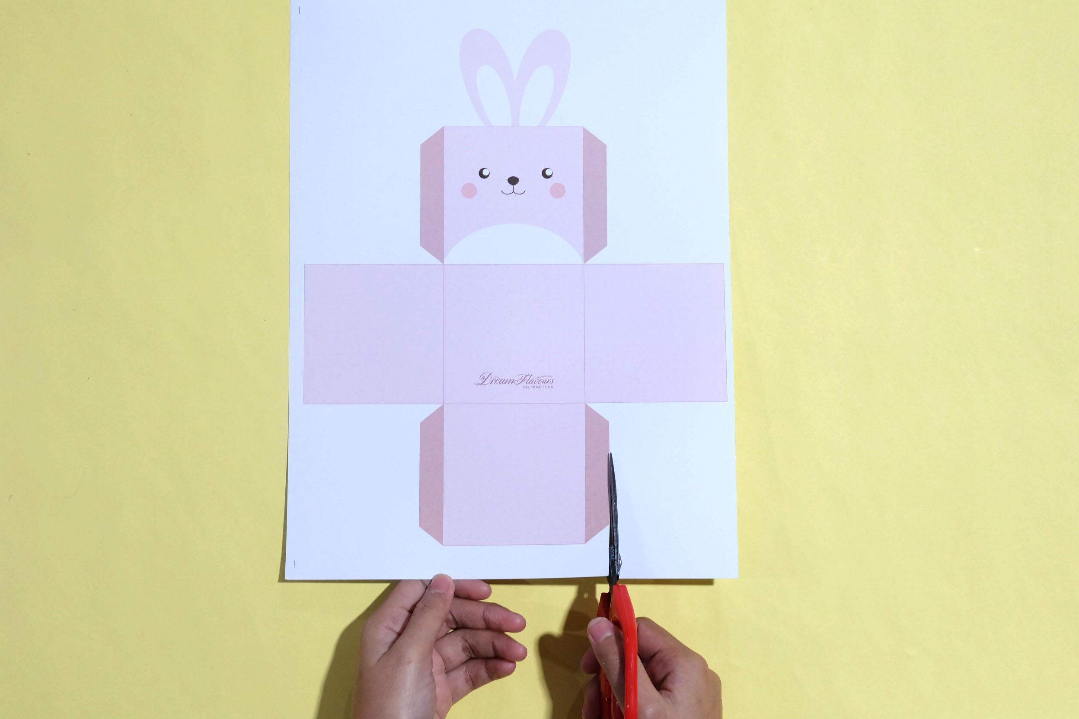
Start by printing and cutting our Bunny Box template where you can download here on a sturdy A4 paper. We recommend using Art Carton but any sturdy paper will do the trick

* Pro tip : pre-cut the folding line using the dull side of a cutter (just gently ! don’t really slice it with the cutter) for easier and neater folding

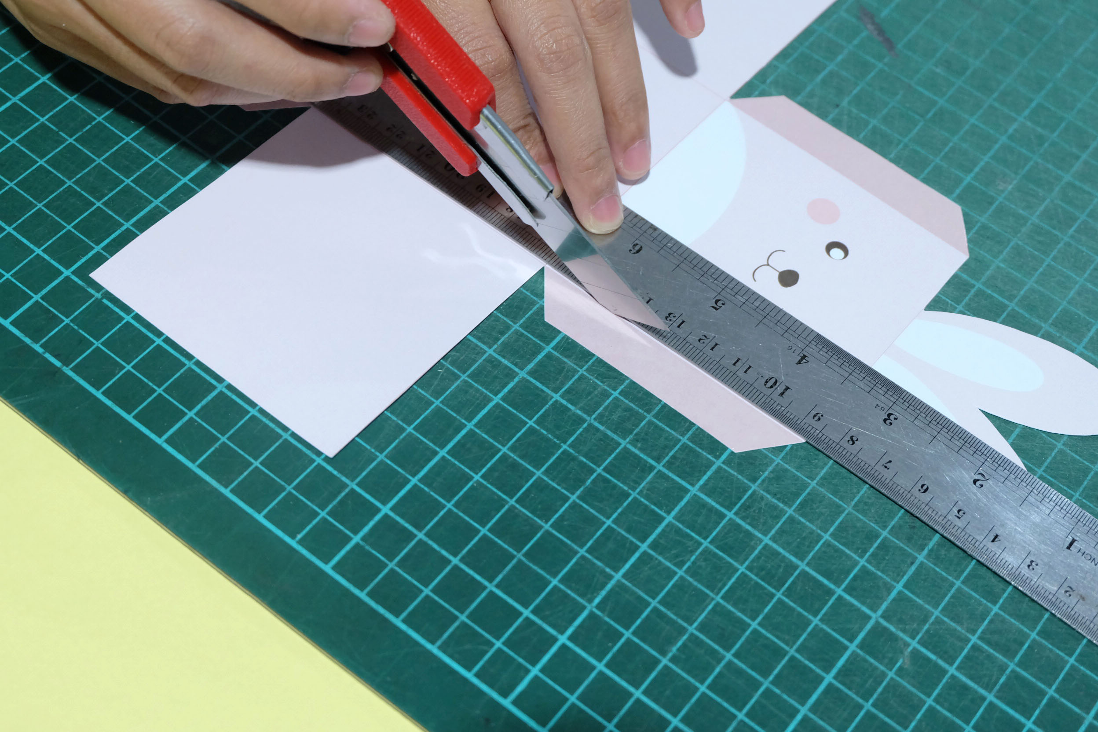

Double tape the darker shades border, fold by the folding line and tape them together to create a box

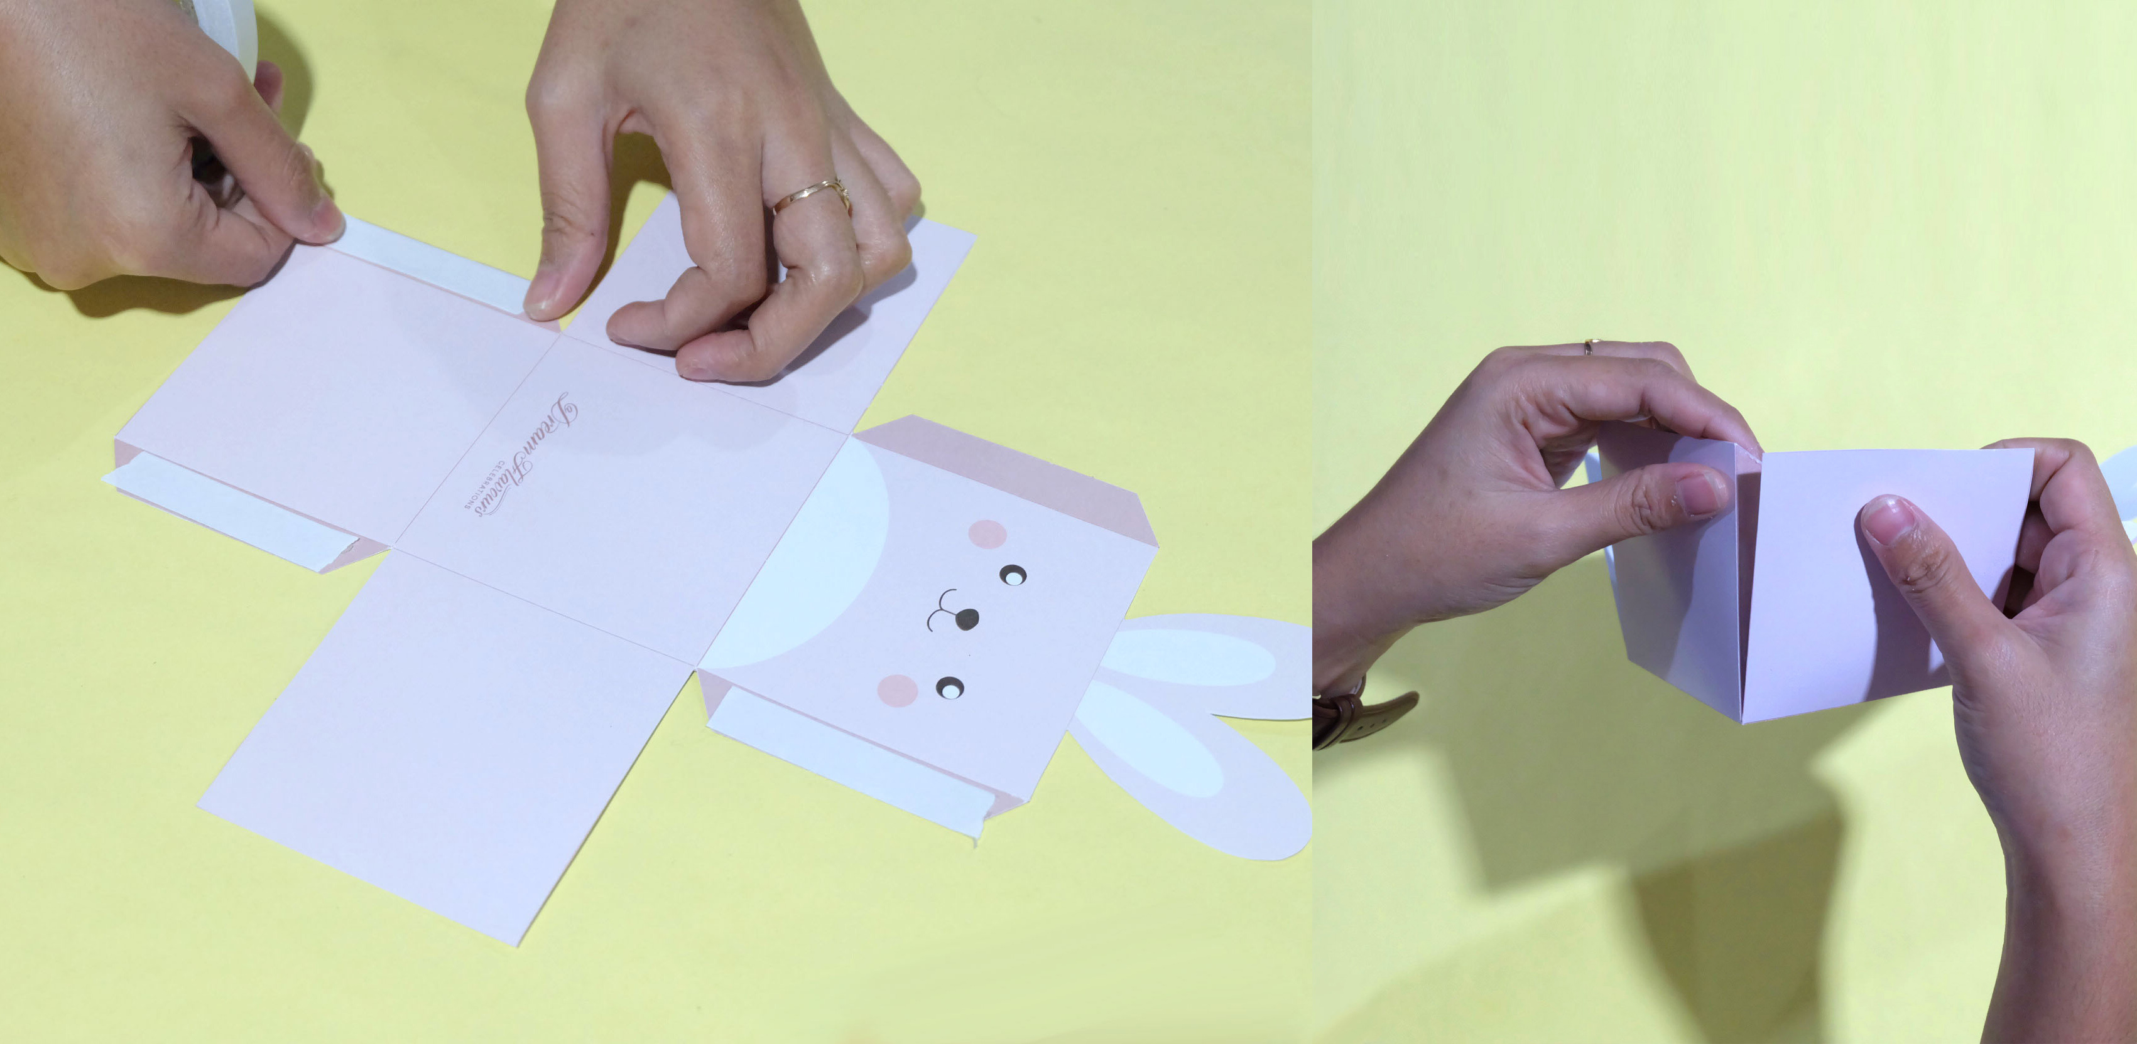

Hot glue pom pom to the back of the box to create the tail of the bunny

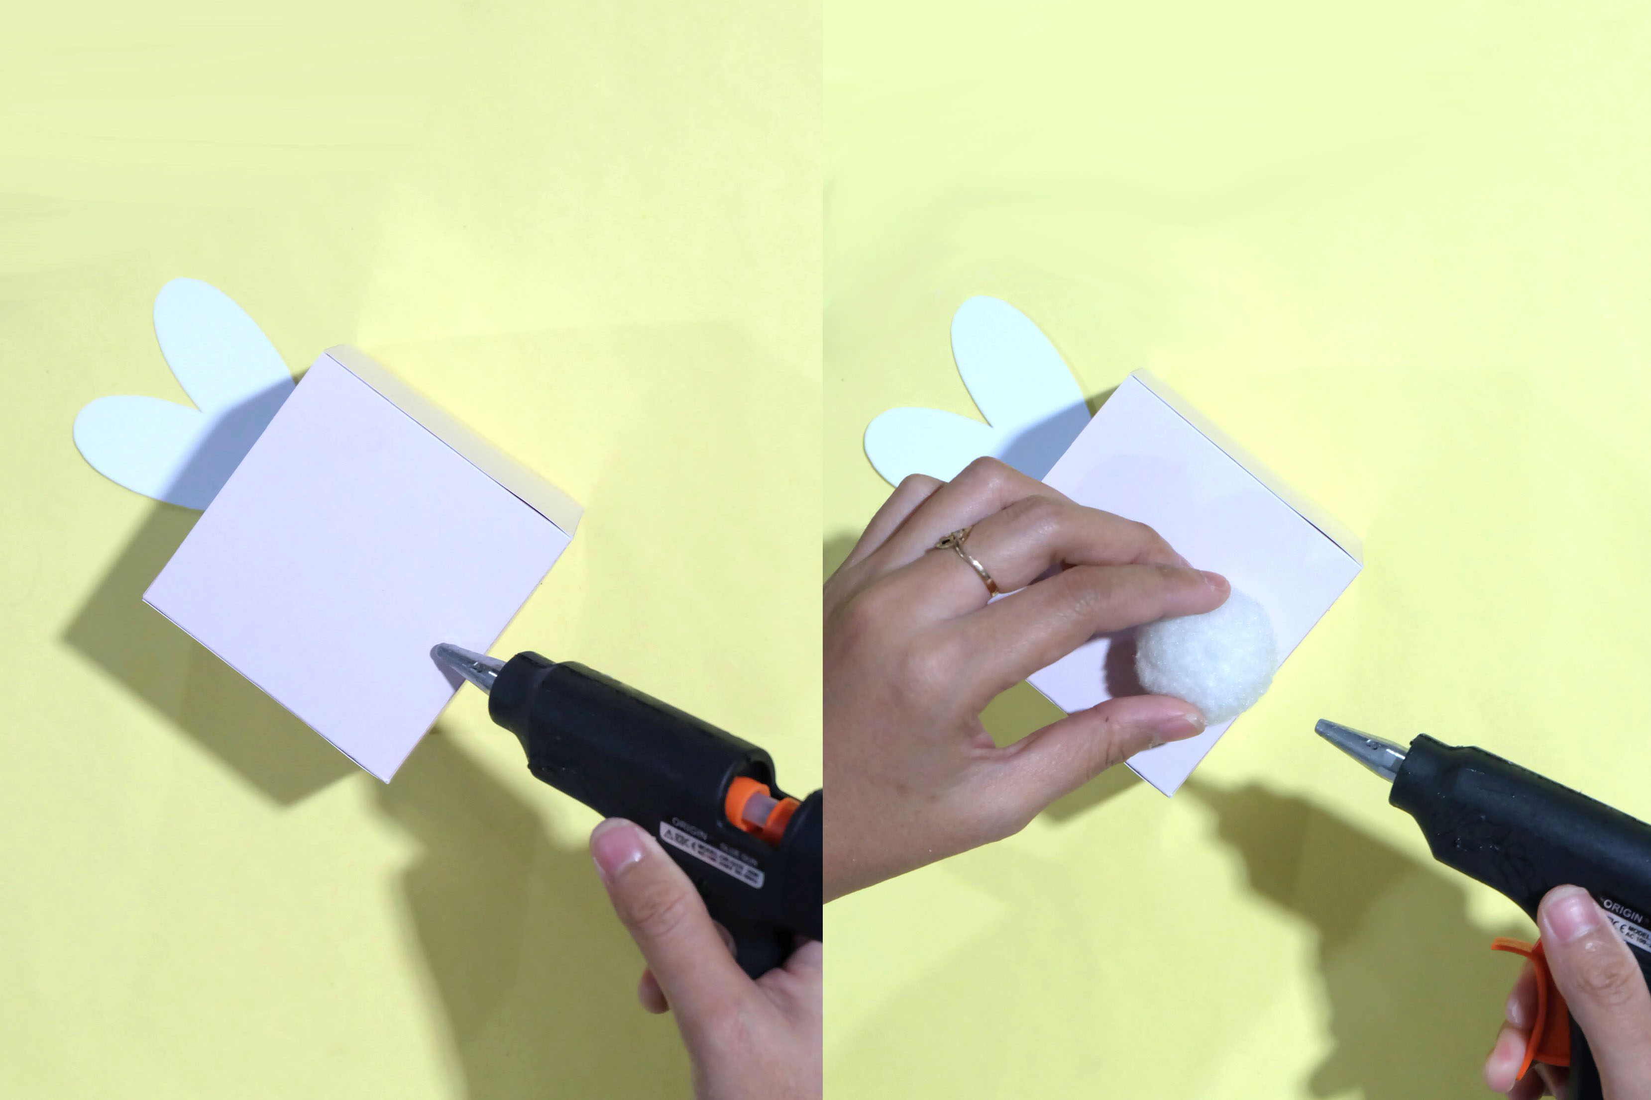

Now just fill them with shredded papers (green shredded paper will look great to create that grass effect) and your preference easter eggs. And VOILA ! there you have it, super quick and easy easter DIY.

